MSSQL Heart Disease Data Analysis
1) Total Patients
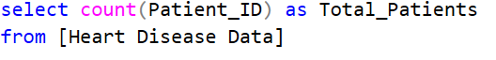
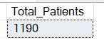
2) Total Patients by Gender
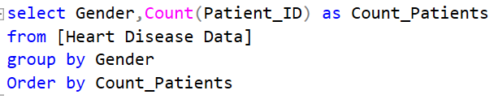
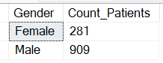
3) Total Patients by Chest Pain and Gender
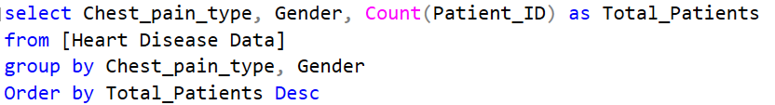
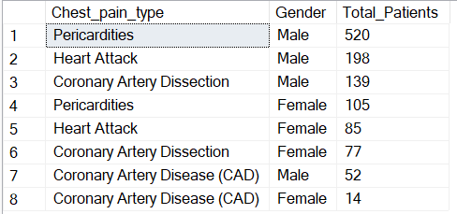
4) Average of Cholesterol and Resting_BPs by Chest Pain Types
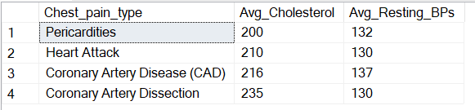
5) Heart Disease Patients by Chest pain type
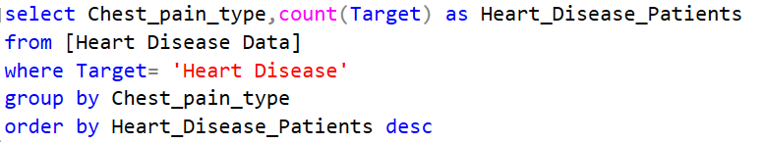
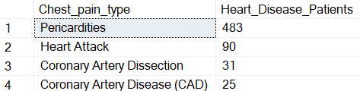
6) Heart Disease Patients by Chest pain type with High Cholesterol and High BP
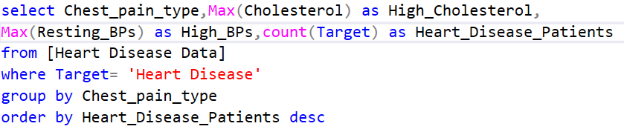
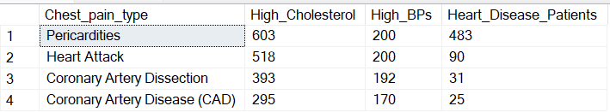
7) Patients with High Cholesterol and High BP by Chest Pain whose age is below 30
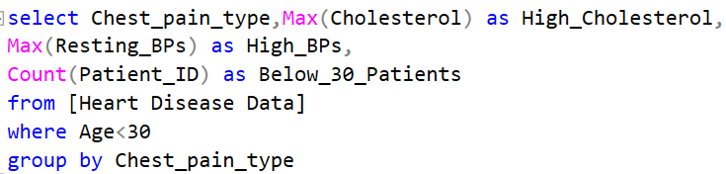
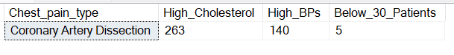
8) Patients with High Cholesterol and High BP by Chest Pain whose age is between 30-39.
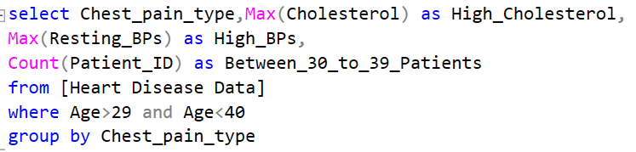
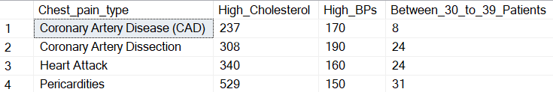
9) Patients with High Cholesterol and High BP by Chest Pain whose age is between 40-49.
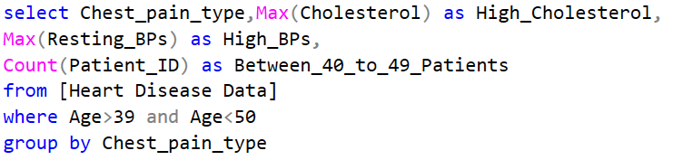
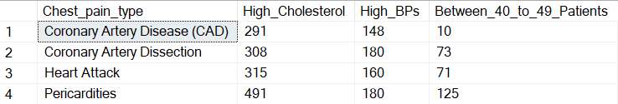
10) Patients with High Cholesterol and High BP by Chest Pain whose age is between 50-59.
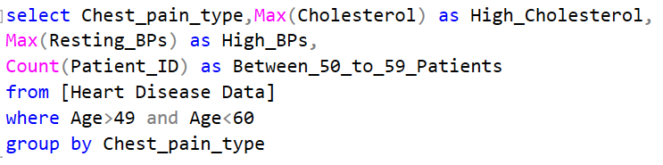
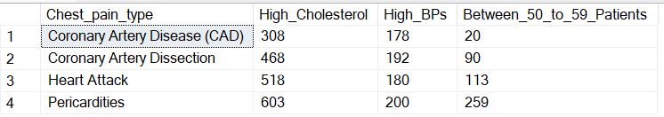
11) Patients with Heart Attack due to Exercise Angina, High Cholesterol and High BP whose age is between 40-49
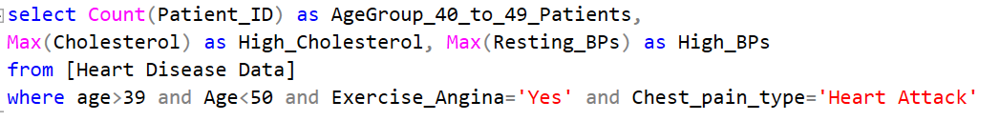
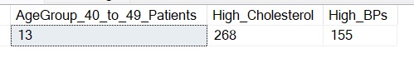
12) Total Patients by Chest pain type
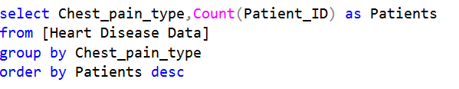
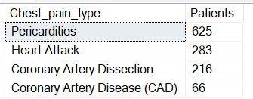
13) Total patients by Chest pain, Gender, with Blood Sugar and without Exercise Angina
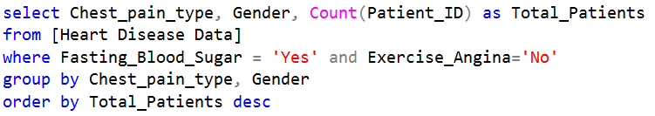
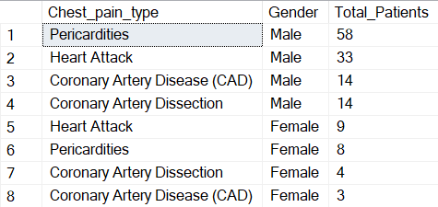
14) Total patients above 60 by Chest pain, with Blood Sugar, with Exercise Angina, with Resting BPs>135 and with High Risk Resting ECG
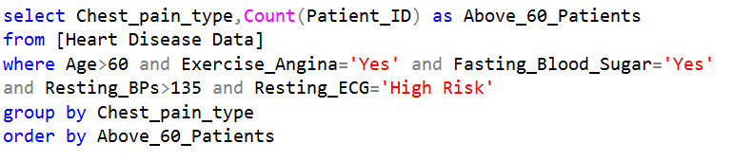
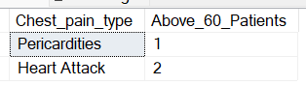
15) Total Patients by Gender, Chest Pain type and with No Heart Disease and Resting ECG is Normal
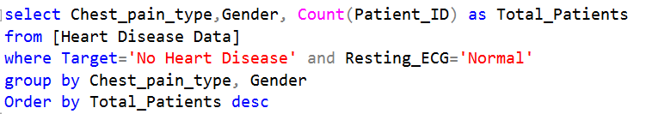
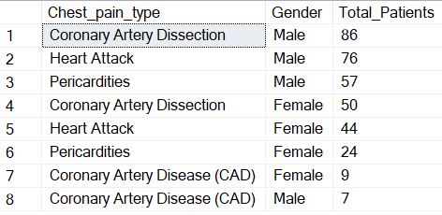
16) Total Patients by Age Groups
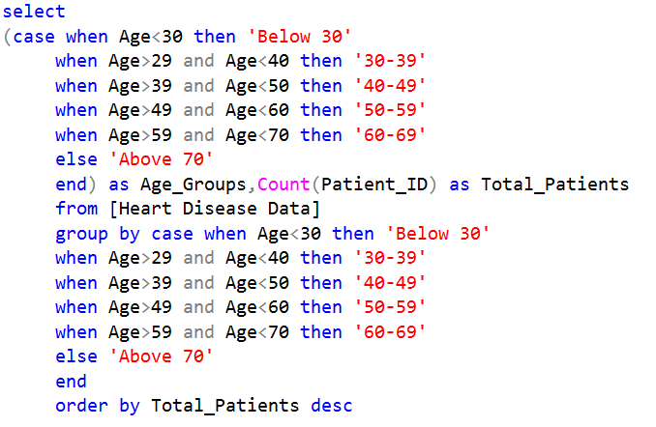
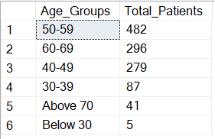
16) Total Patients with Fasting Blood Sugar by Age groups
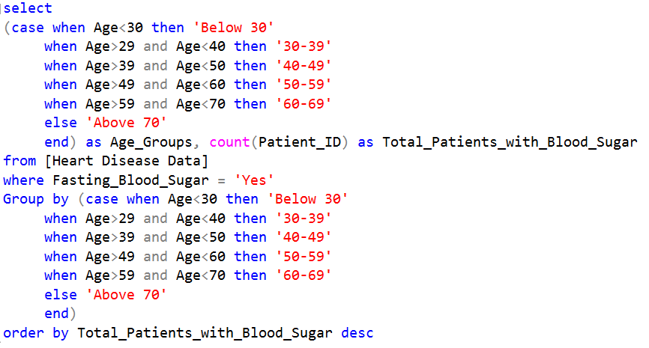
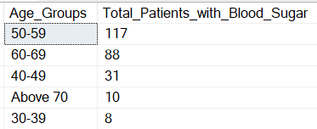
17) Total Patients with Heart Attack, Exercise Angina and with High Risk Resting ECG by Age groups
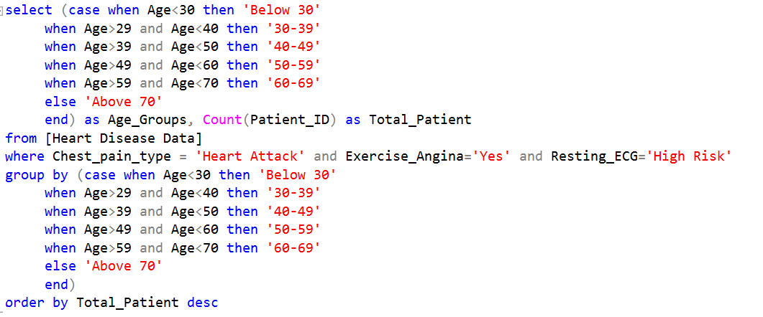
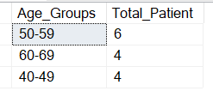
18) Total Patients with Coronary Artery Disease, with no Heart Disease, with high Cholesterol and Resting ECG is Abnormal by Age groups
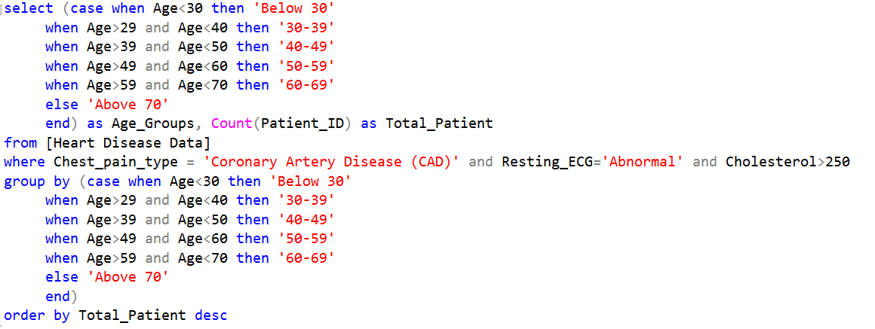
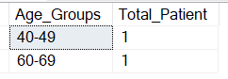
19) Total Patients with High Cholesterol by Age Groups and by Chest Pain Types
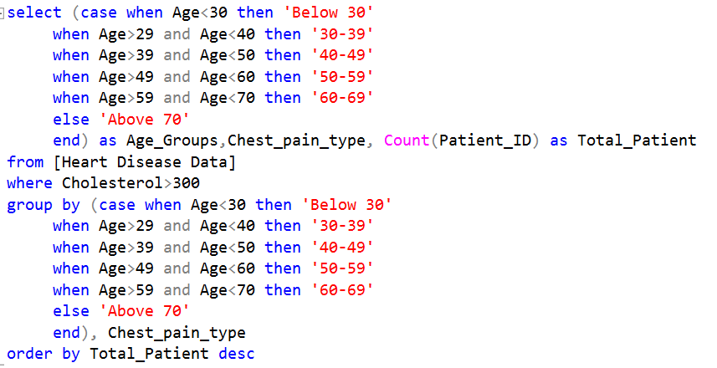
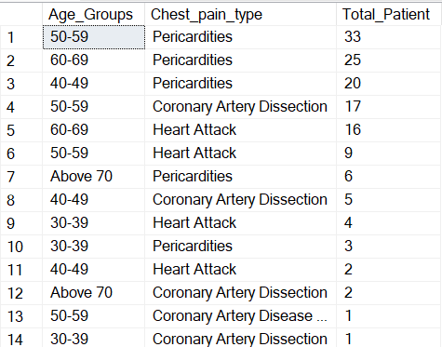
20) Total Patients with High Risk Resting ECG and with Heart Disease by Age Groups and by Chest Pain Types
